#Briefly explain the role of Hypertext Transfer Protocol (HTTP) in web communications. [5 marks]

Why is HTTP 1.0 called a stateless protocol? [5 marks]

HTTP is an application protocol for transferring hypertext eg. HTML. It is a request-response protocol in the client-server computing model. It was designed to permit intermediate network elements to improve or enable communications between clients and servers.

A stateless protocol means that the server maintains no information about the clients past requests.

Describe how an e-commerce site can keep a purchase record of each of its customers using cookies. [10 marks]

Cookies maintain the state at the sender/receiver over multiple HTTP transactions, they have six parameters.

* Name of the cookie
* Value of the cookie
* Expiration date of the cookie
* Path the cookie is valid for
* Domain the cookie is valid for
* The need for a secure connection

This allows the site to keep a record of a user by identifying them and storing their information. In the case of an e-commerce website it can be used to keep a record of a user’s purchase history.

Consider the institutional network below, which is connected to the internet via a 15 Mbps access link. Suppose that the average object size is 960,000 bits and that the average request rate from the institution's browsers to the origin servers is 15 requests per second. Also suppose that the amount of time it takes from when the router on the Internet side of the access link forwards an HTTP request until it receives the response is 2 seconds on average. Model the total average response time as the sum of the average access delay (that is, the delay from the internet router to the institution router) and the average Internet delay. For the average access delay, use Δ(1-Δβ), where Δ is the average time required to send an object over the access link and β is the arrival rate of objects to the access link.

Find the average response time. [6 marks] 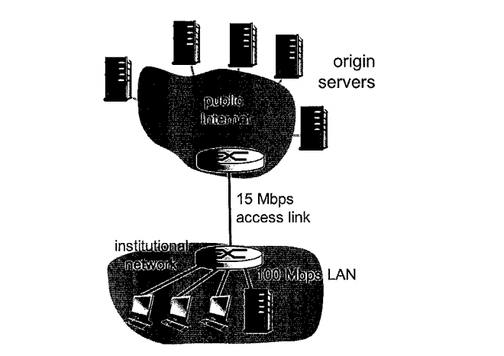

* Access link rate: 15Mbps
* LAN rate: 100Mbps
* Average object size: 960,000 bits = 0.96Mb
* Average request rate: 15 r/s
* RTT: 2 seconds

**Average response time**

△ = $average object size/access link rate$

△ = 0.96/15 = 0.064 s/r

B = 15 r/s

Average access delay = Δ(1-Δβ)

$\frac{0.064}{Δ(1-Δβ)}$ = $\frac{0.064}{1-(0.064x15)}$ = 1.6 seconds

Avg. response time = avg. access delay + avg. internet delay

Avg. response time = 1.6 + 2 = 3.6 seconds.

Find the total response time if a cache is installed in the institutional LAN with a miss rate of 0.4. Using above data [6 marks]

Miss rate = 0.4

Average access delay = $\frac{△}{1-MissRate△B}$ = $\frac{0.064}{1-(0.4 x 0.064 x 15)}$ = 0.104 seconds

Avg. response time = 0.104 + 2 = 2.104 seconds

Total response delay = (0.6 x 0) + (0.4 x 2.104) = 0.842 seconds

Consider what happens when a browser (i.e. a HTTP client), running in some user's host, requests the URL somesite.com/index.html. In order for the user's host to be able to send a HTTP request message to the Web server [www.somesite.com](http://www.somesite.com/). Explain the steps through which the IP address for such a hostname is obtained by the client. [12 marks]

* Firstly, the client queries the ISP of the IP of [www.somesite.com](http://www.somesite.com)
* The ISP queries the root server to find IP address of .com DNS server
* ISP queries .com server to find IP address of somesite.com DNS server
* ISP queries somesite.com to find IP address of [www.somesite.com](http://www.somesite.com) DNS server
* ISP returns IP address of [www.somesite.com](http://www.somesite.com) to the client
* Client is now able to access the host.

What is a DNS? [1 mark]

Domain name system is a hierarchical decentralised naming system for resources connected to the internet. It assigns a hierarchy of names to IP addresses.

Eg. Google.ie = 209.85.203.94

What protocol do DNS use? [2 marks]

* Root servers resolve top level domains (.ie, .com, .net etc.)
* TLD servers are responsible for their respective subdomains (google.ie, amazon.ie, etc.)
* Authoratize servers are responsible for their subdomains (foo.bar.net etc.)

What would the implications be if all the DNS servers worldwide went offline at the same time? [2 marks]

If all of the DNS servers in the world went down at the same time, domain names would be unresolvable, however if you knew the exact IP address of the domain you could still access it.

Describe in detail the operation and benefits provided by a Content Distribution Network (CDN). [10 marks]

CDN’s were built to relieve some of the pressure that is on the internet, it was never built to handle live HD video streaming, online flash sales or the demands of massive amounts of data so CDN’s work by caching links to certain content. For example if a user in Japan wanted to access a site in Milan that was having a sale before CDN’s the user in Japan would need their connection to hop around the world to get to the endpoint for the Milan site. However, now with CDN’s the CDN server nearest the user in Japan will have cached the Milan site’s content and deliver it to the Japan user without having their connection travel around the globe saving much needed time and resulting in much greater performance.

Benefits of a business using a CDN include

* Performance
* Availability
* Intelligence
* Security

What is the role of DNS in a Content Distribution Network (CDN)? [4 marks]

The DNS smartly chooses the best server to handle the clients request. For example if a user is trying to access a site while in California the DNS will resolve the sites IP address to their server on the West coast of the USA, while if in Virginia the DNS will resolve the IP address to their server on the East Coast of the USA.

Does the DNS have to be modified to support the CDN? [3 marks]

**Unsure of this Answer if someone could explain the answer?**

You could say that the DNS would need to be modified to accept alternative query names or the contrary that it doesn't need to be modified as it will use the authoritative server determines the client's location and then returns the CDN server selection?

NS record has to be pointed to CDN server..

What information, if any, must a CDN provide to a DNS? [3 marks]

**The IP address of the request?**

**Or**

**The server that the CDN points to?**

What is the role of a SIP registrar? [5 marks]

Session Initiation Protocol is a communications protocol for signalling and controlling multimedia communication sessions in applications of internet telephony for voice and video calls, in private IP telephone systems as well as instant messaging over IP networks.

It defines the specific format of the messages exchanged and the sequence of communications for operation of the participants.

How is the role of a SIP registrar different from that of a home agent in Mobile IP? [5 marks]

**If anyone could shed some light on this?**

How can a multimedia application recover from packet loss without the need for retransmission? [3 marks]

Describe in detail three methods discussed in lectures. [12 marks]

**Answer needed?**

In BitTorrent, suppose Alice provides chunks to Bob throughout a 30-second interval. Will Bob necessarily return the favor and provide chunks to Alice in the same interval? [3 marks]

Not necessarily, Bob will only supply data to his top 4 peers and a random 5th peer.

Suppose Alice doesn’t provide data at a high enough rate to beat Bob’s top four peers, then Bob will not be satisfied and will not return the favour by sending data in return.

Consider Trudy joins the BitTorrent without possessing any chunks. Without any chunks, she cannot become a top-four uploader for any other peers, since she has nothing to upload. Then how will Trudy get her first chunk? [6 marks]

Firstly, there are people called seeds in bittorrent who will simply not expect anything in return for sending any packets as they already have the completed file, others will have different leach settings and will only expect 1 packet in return for every 4 sent or some will have a 1 to 1 ratio for sent and received packets. So there will always be a seed with a completed file that will supply a new user with their first chunk of data.